Project 1 Lab Interim Report
Technical Report

Justin Collier
IEEE # 96640574
Texas Tech University
April 2020

Abstract
This Report will talk about the technical aspects of making a rover move atop a metallic tape without veering off course. Two DC motors move the rover forward and backward, as well as turning in both directions. It will also describe the use of a comparator circuit to detect whether the DC motors are drawing more than 1 amp. This will be done using a Basys3 board, an H-Bridge Motor Driver, a 4-digit 7-segment display, four inductive proximity sensors and various LEDs, and power sources.

Table of Contents
List of Figures…………………………………………………………………………….4
- Introduction……………………………………………………………………………5
- Hardware………………………………………………………………………………5
2.1 Basys 3 Board…………………………………………………..…………………5
2.2 LEDs………………………………………………………..……………………..6
2.3 PMOD Ports………………………………………………………………….……7
2.4 4-Digit 7-Segment Display………………………………………………………..8
2.5 H-Bridge…………………………………………………..………………………9
2.6 Current Detection Circuit………………………………………………………...10
2.7 Rover Chassis……………………………………………………….……………13
  - Inductive Proximity Sensors……………….……………………….……………13
  - 3D-Printed IPS Mounts…………………………………………………………..14
3. Software………………………………………………………………….…………..14
3.1 Pulse Width Modulation………………………………………………...……….14
3.2 Inductive Proximity Sensor code ……………...…………………………….…..16
3.3 4-Digit 7-Segment Display……………………………..…………………….….17
3.4 LEDs…………………………………………………………………….……….19
3.5 Current Protection Circuit………………………………………………………..19
4. Results………………………………………………..………………………………20
5. Conclusion………………………………………………...…………………………21
Acknowledgments……………………………………………………………………22
References………………………………………………………………………..…..23
Appendix A Budget and Gant Chart………………………………………...……….24
Appendix B Written Lab Report Evaluation Form…………………………………..27

List of Figures/Tables

Figure 1: Basys 3 Board………………………………………………………………….………..5
Figure 2: LEDs……………………………………………………………………...……………..6
Figure 3: PMOD Ports…………………………………………………………….…..…………..6
Figure 4: PMOD Pins……………………………………………………………………………..7
Table 1: PMOD Pin Assignment………………………………………………………………….8
Figure 5: 4-Digit 7-Segment Display…………………………………………….………………..8
Figure 6: Direction Display……………………………………………………………...………..9
Figure 7: Current Detecting Schematic………………………………………………….….……10
Figure 8: Current Detecting Simulation……………………………………….……………....…11
Figure 9: Implemented Current Detecting Circuit…………………………………...……..……11
Figure 10: Oscilloscope Trace for Output-1……………………………………………..………12
Figure 11: Oscilloscope Trace for Output-2…………………………………………………..…12
Figure 12: Sensor Layout……………………………………………………….………………..13
Figure 13: Front IPS Bracket ……………………….…………………………….……….……..14
Figure 14: Front IPS Bracket Mounted …………………..……………………….……………..14
Figure 15: Figure :25% Duty Cycle……………………………………………………….……..15
Figure 16: Figure :50% Duty Cycle……………………………………………………….……..15
Figure 17: Figure :75% Duty Cycle……………………………………………………….……..16
Figure 18: IPS Code…………..………………………………………………………...………..17
Figure 19: Multiplexing Delay……………………………………………………………….…..18
Figure 20: Multiplexing…………………………………………………………………….……18
Figure 21: Current Protection Code………………………………………………………….…..19
Figure 21: Total Budget………………………………………………………………………….24
Figure 22: GANTT Chart………………………………………………………………..……….26

- Introduction

This technical report describes the process of moving a rover move atop a metallic tape without veering off course. Two DC motors move the rover forward and backward, as well as turning in both directions. This is accomplished using four inductive proximity sensors, each tasked with looking for the metallic tape. Depending on the inputs from these sensors, the Basys3 board will output a pulse width modulation (PMW) to the H-Bridge Motor Driver. The Basys3 board will output either a 0%, 25%, 50%, 75% or 100% PWM duty cycle to control the speed of the rover. A current detection circuit is also used to indicate, and display whether the motors are drawing an amperage greater than 1 amp from the 9.2V rechargeable lithium ion battery.

- Hardware

  - Basys 3 Board
The Basys3 board, as seen in Figure 1, is an out-of-the-box, ready-to-use digital circuit development platform featuring Xilinx Artix-7 FPGA software. This board uses Field Programmable Gate Array (FPGA). It is powered by a five-volt portable power supply connected through a micro-USB cable,
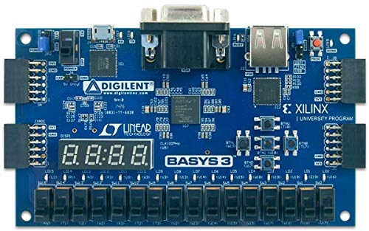
Figure 1: Basys 3 Board

  - LEDs
LEDs 0-7 are located above each respective switch as seen in Figure 2. These are used to indicate which direction and PWM signal is sending an output to the onboard microcontroller.
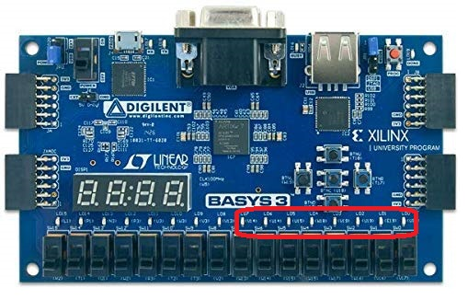
Figure 2: LEDs
  - PMOD ports
The Basys3 board offers 4 sets of PMOD ports which can be configured for input or output from each pin, depending on what the user intends them for.
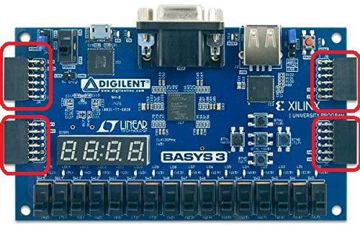
Figure 3: PMOD Ports

This project uses two PMOD headers. The pin layout for each header can be seen in Figure 4. For header JA, Pins 1-4 and 6-10 are used as outputs to control speed and direction of the two motors, as well as inputs for the current protection circuit. The current protection circuit will be covered more in 2.6. For header JB, pins 1-4 are used to control inputs from the inductive proximity sensors. These sensors will be covered more in 2.8. Ports 5 and 11 are ground pins and pins 6 and 12 are VCC pins which output 3.3V. For a more detailed explanation of the pin layouts, refer to Table 1 below.
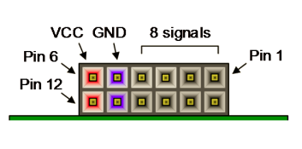
Figure 4: PMOD pins

Table 1 below indicates what each PMOD pin is used for
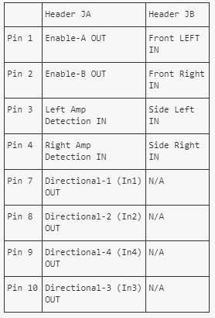
Table 1: PMOD Pin Assignment

  - 4-Digit 7-Segment Display
As illustrated in Figure 5, the Basys3 board incorporates a 4-digit 7-segment display that outputs the current direction of each motor, as well as the PWM duty-cycle that's being outputted to the H-Bridge.
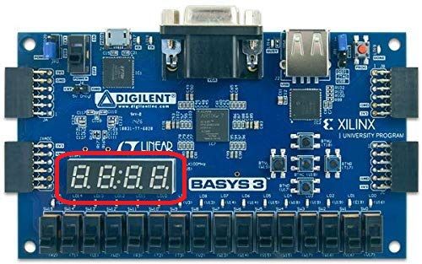
Figure 5: 4-Digit 7-Segment Display

Digit 4 displays the direction of the left motor while Digit 1 displays the direction of the right motor as seen in Figure 6.
.
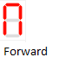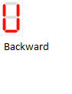
Figure 6: Direction Display

Digit 2 and Digit 3 displays the current PWM duty cycle being outputted. This is performed through the use of multiplexing. This is a way of sending multiple streams of signals through one shared wire, allowing the use of far fewer connections than what would normally be needed traditionally.

  - H-bridge
As described in 2.3, the PMOD ports are connected to the corresponding pins on the H-Bridge Motor Driver. The H-Bridge L298 Motor Driver is a high voltage, high current dual full-bridge driver intended for the use of two bidirectional Dc motors. As seen in Table 1, this circuit takes in 6 inputs. Two input signals, Enable-A and Enable-B are used to independently enable and disable the two motors. These inputs are tied to the PWM outputs from the Basys3 board. Depending on the inductive proximity sensor inputs, the Basys3 board will determine which PWM signals will be sent to these pins. This will be covered more in 2.8. Four inputs, In1, In2, In3, and In4 are used to set the bridge (motor direction) when the Enable input is set to high. In1 and In2 sets the output for Enable-A while In3 and In4 sets the output for Enable-B. Voltage cannot pass through to the motors if the Enable inputs are set to a low state, no matter the bridge inputs. This allows each motor to spin in either direction independently of one another using the integrated L298 chip on the H-bridge motor driver.

  - Current Detection Circuit
The current detection circuit detects when the current from the motors connected to the H-Bridge is greater than 1 Amp. It does this by comparing the output of the SNS-A and SNS-B ports on the H-Bridge to a 1-volt reference. If the signal is greater than one amp, the current detection circuit will send 3.3-volt signal to the Basys 3 board for further processing. (Figure 7)
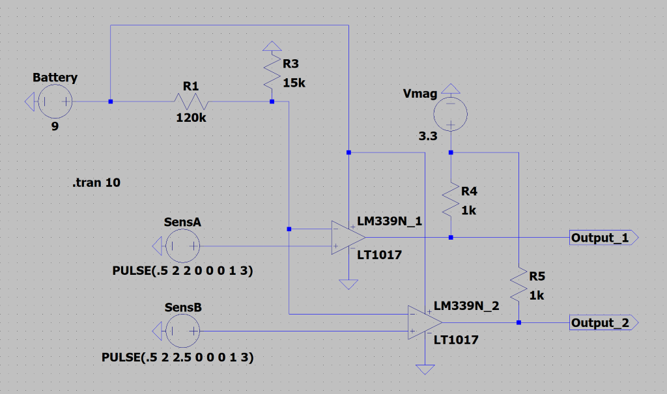
Figure 7: Current Detecting Schematic

To obtain the refence voltage, the current detecting circuit takes a DC signal from the 9-volt battery and reduces the voltage using a potentiometer. The LM339N comparator then compares the reference voltage to the SNS-A and SNS-B ports. The output is then amplified to 3.3-volts in order to meet the requirements of the Basys 3 board using a 1k-ohm pullup resistor. If motor amperage exceeds 1 amp, the current detecting circuit will then send the PWM signal to the Basys 3 board. The circuit is doubled to process both signals coming from the DC motors.
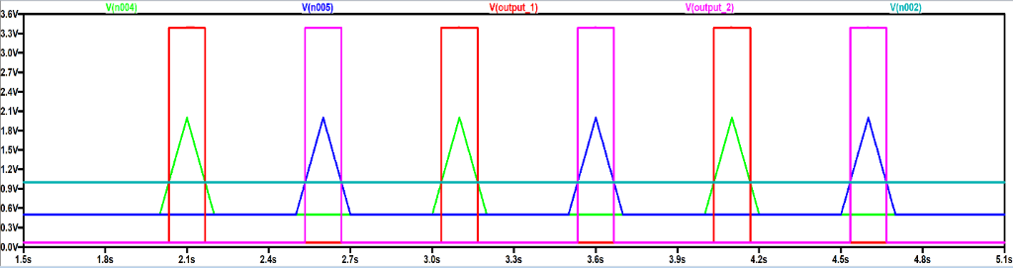
Figure 8: Current Detecting Simulation

As shown in Figure 8 above, if either the SNS-A(green line) or the SNS-B(blue line) gets above the 1-volt threshold(teal line), output-1(red line) and output-2(pink line) will peak at 3.3-volts respectfully.
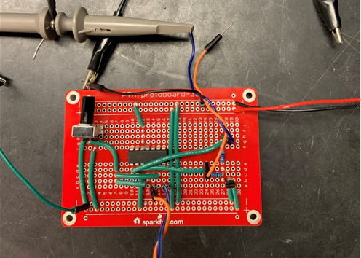
Figure 9: Implemented Current Detecting Circuit

As shown in Figure 9 above, the current detection circuit is constructed on a solderable breadboard. This board is located underneath the Basys 3 board on the rover chassis.
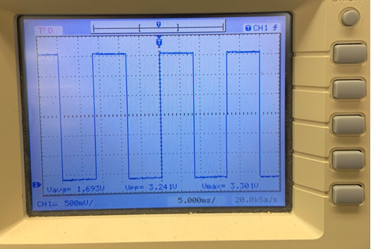
Figure 10: Oscilloscope Trace for Output-1
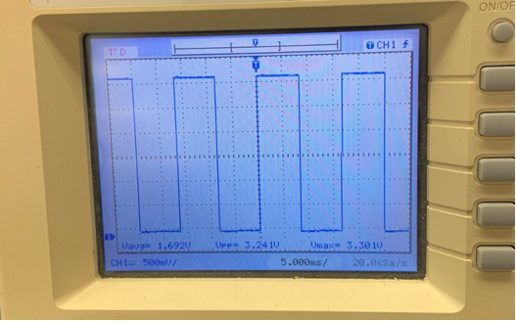
Figure 11: Oscilloscope Trace for Output-2
As shown in Figures 10-11, both output-1 and output-2 shows a 2-volt, 60 Hz square wave. This output was from the function generator, being used to simulate outputs from the SNS-A and SNS-B ports.
  - Rover Chassis
The Rover chassis incorporates two bidirectional DC motors (TECO TFK280SC-21138-45) intended to drive the track driven rover chassis. These motors are connected directly the H-Bridge, which tells the motors what direction to turn and how fast. The top of the chassis is used to mount the H-bridge, Basys 3 board, 3 batteries, current protection circuit, and the four inductive proximity sensors

  - Inductive Proximity Sensors
Inductive Proximity Sensors detect metal objects from a short distance without physically touching the object. In this case, the object is metallic tape. The sensor takes in 6 volts. Once the metallic tape is at least halfway underneath the sensor, and is at most 8mm above the tape, the sensor will then output 6v to the Basys3 board for processing. The rover sports 4 sensors, with the layout being depicted in Figure 12 down below.
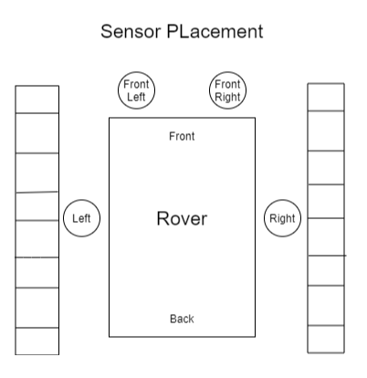
Figure 12: Sensor Layout

  - 3D-Printed IPS Mounts
In order to mount the Proximity Sensors to the rover, two different models were designed for mounting in the front and on the sides. The 3D modeling software used is Fusion 360, and the 3D-Printer used is a REPRAPGURU DIY Prusa i3. As seen in Figure 14, the front mount screws onto the top of the chassis and is used to mount two of the sensors. As shown in Figure 13, the side mount is a clip-on style mount that slides onto the top of the chassis frame. This mount holds one sensor, with the rover sporting one mount on each side of the rover. The complete layout can be seen in Figure 12 above.
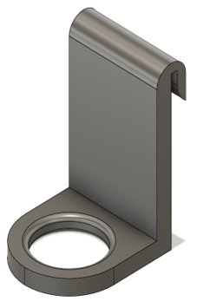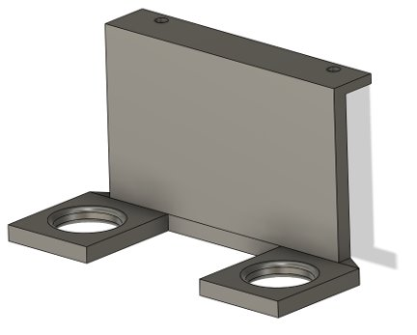
Figure 13: Front IPS Bracket Figure 14: Front IPS Bracket Mounted

- Software

3.1 Pulse Width Modulation
In order to control the rover, the Basys3 board is used to output PWM signals and directional signals, analyze and compute incoming signals, and display live information. This is a FPGA development board using the hardware-description based programming language, Verilog. The Basys3 board used control 5 different speeds through the use of PWM signals and various duty cycles. The PWM outputs are dependent on the inputs from the Inductive Proximity Sensors. This will be covered more in 3.2. Figures 15-17 show a visualization of the different PWM signals on an oscilloscope.

Duty cycle of 25%
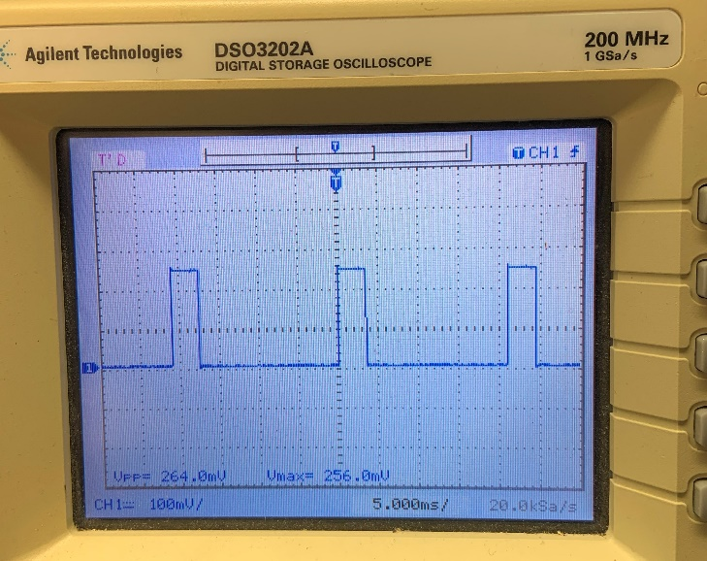 Figure 15: 25% Duty Cycle
Duty cycle of 50%
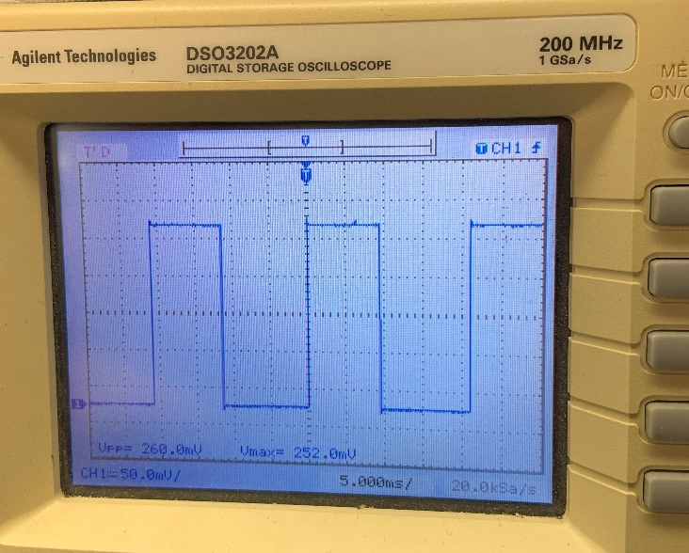 Figure 16: 50% Duty Cycle
Duty cycle of 75%
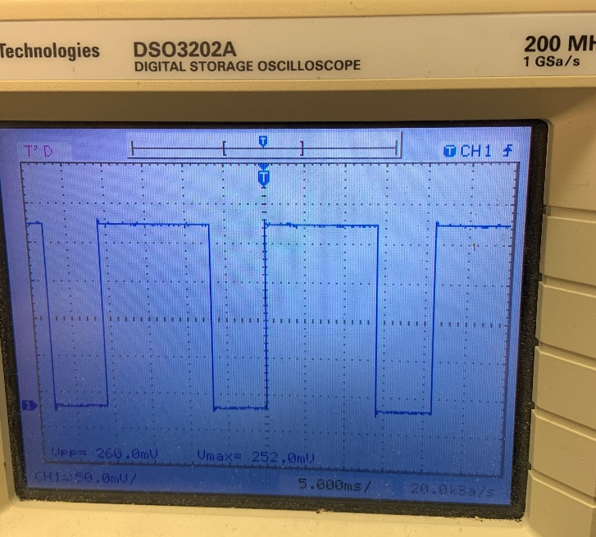 Figure 17: 25% Duty Cycle
Duty cycle of 100% is visualized as an active high signal.

3.2 Inductive Proximity Sensor code
As seen is Figure 18 below, this section of code is implemented to keep the rover above the metallic tape. If any one of the four sensors see the metallic tape, then a specific set of instructions is sent to keep the rover on course. More specifically, this is the code that determines what speed and direction each motor will move, depending on the input from the proximity sensors. If the front left sensor is triggered, then the right and left motor will move forward at 100%, and 50% duty cycle respectively. This will cause the rover to slightly turn left. If the front right sensor is triggered, the right and left motor will move forward at 50%, and 100% respectively. This will cause the rover to slightly turn right. If the side left sensor is triggered, then the right and left motor will move forward at 100%, and 25% duty cycle respectively. This will cause the rover to aggressively turn left. If the side right sensor is triggered, the right and left motor will move forward at 25%, and 100% respectively. This will cause the rover to aggressively turn right. The front sensors are used to slightly correct the rover, and the side sensors are used to aggressively correct the rover.
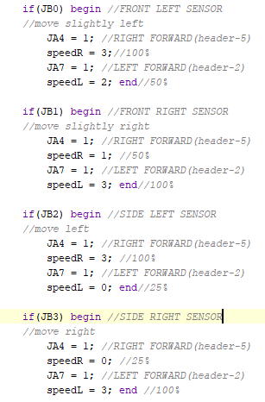
Figure 18: IPS Code
3.3 4-Digit 7-Segment Display
In order to produce a proper output from the 4-digit 7-segment display, multiplexing must be used (Figure 20). This is a way of sending multiple streams of signals through one shared wire, allowing the use of far fewer connections than what would normally be needed traditionally. This is done by enabling one 7-segment display at a time, with a delay in between each digit. (Figure 19)
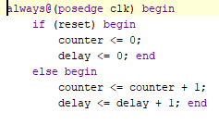
Figure 19: Multiplexing Delay

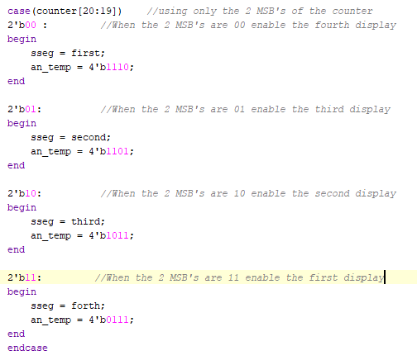
Figure 20: Multiplexing

The code creates a 20-bit counter for the multiplexing. The MSBs are used for digit selection. This holds the digit next in line so it’s ready to be displayed on the 4-digit 7-segmet display. If you were to watch this happen in slow motion, you would see each digit light up individually.
3.4 LEDs
Each PWM and directional output signal has a corresponding LED. This is used to verify the outputs of the signals being sent to the H-Bridge. LED 0-3 corresponds to each PWM signal variant, while LED 4-7 corresponds to each direction for the two motors.

3.5 Current Protection Circuit
The current protection circuit detects when the motors have exceeded more than 1 amp. When this happens, the circuit will send a 3.3V PWM signal to two pins on the Basys3 board. Pin 2(JA2) is in the input for the left motor, while Pin 3(JA3) is the input for the right motor. When the Basys3 board receives a signal from the current protection circuit, it will disable the last three digits on the 4-digit 7-segment display in order to inform the user that one of the motors has exceeded 1 amp, as seen in Figure 21.
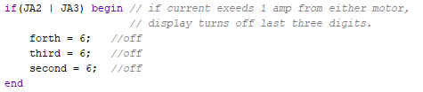
Figure 21: Current Protection Code

- Results
The Verilog code uploaded to the Basys 3 board detects when a number of inductive proximity sensors gets triggered. The sensors are triggered by a metallic tape underneath the rover in the event the rover veers off course. The Basys 3 board tells the H-bridge which direction and speed to spin each motor on the rover. The 4-digit 7-segement display tells the user which direction each motor is going and at what PWM cycle. The current sensing circuit will detect when either of the motors reach an amperage greater than one amp and relay this information to the Basys board. The Basys 3 board will inform the user by turning off the last three digits on the 4-digit 7-segment display through multiplexing. Due to real world complications, the project never ended up getting completed. Further testing for the IPS code was needed.

5.Conclusion
Due to the use of the H-bridge, Basys 3 board, comparator circuit, and the inductive proximity sensors, this project was possible. The rover can move forward and backward as well as left and right along a metallic tape without veering off cource. It is also able to display the direction of each motor and the duty cycle of two motors. The Basys board combined with the current sensing circuit can sense and display when the two motors reach more than one amp.

Acknowledgements
First off, I would like to thank my lab partners JT Crainer and Blane Tanley for the amazing work they’ve put into this project. I would also like to thank Daniel Ayala for the extremely helpful Verilog tutorials he has posted online over at youtube.com. Most importantly, I would like to thank Dr. Hemmert for his advice, and constructive criticism for the presentations, Verilog code, Budgets and GANTT charts, and all things hardware related.

References
- Seven Segment LED Multiplexing Circuit in Verilog
http://simplefpga.blogspot.com/2012/07/seven-segment-led-multiplexing-circuit.html
- “Basys-3 FPGA Board Reference Manual.”
https://reference.digilentinc.com/_media/basys3:basys3_rm.pdf
- Daniel Ayala
https://www.youtube.com/channel/UCoPga5fpXGBXyXoTJck3cJQ

Appendix A
Budget / Gantt Chart
The Budget for this project displays both estimated and real time costs for this project. It displays the direct labor cost by calculating each group members personal hours and external help hours. The budget calculates the overhead that is required to sustain the group as well as the cost to rent each piece of equipment. There is also a list of materials that were bought and used by the group for the project. Although further testing was required, the project was underbudget with the estimated cost being $27.396.51 and the actual cost coming to $12,854.32. This equates to 46.92% under budget. (Figure 22)
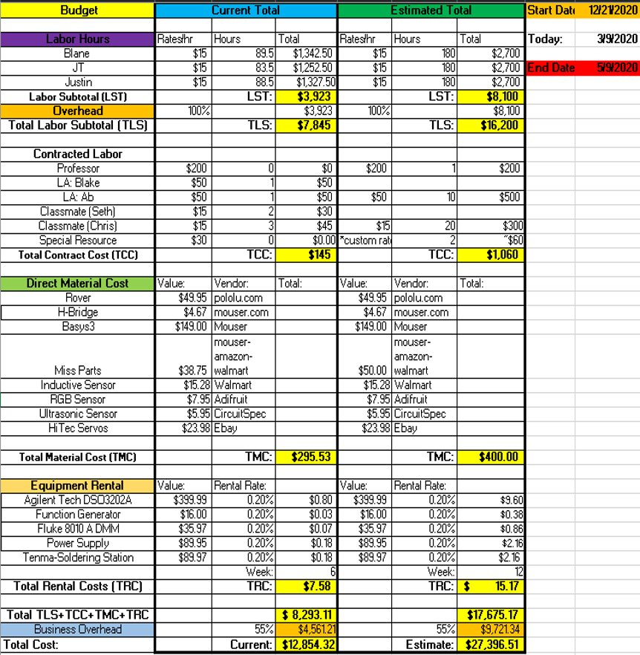
Figure 22: Total Budget
The GANTT Chart was used to display future goals, deadlines, and real time progress. This allowed the group to compare current progress with the expected deadlines. As seen in Figure 23, the goals were split into seven different categories. Each category assigned specific goals to each group member which consisted of hardware, software, and admin related tasks. Different colors were assigned to indicate the progress level of each task. The colors would show either incomplete, mildly behind, majorly behind, or complete with the colors being grey, yellow, red, and green respectively. The blue dotted line showed the current date and the purple bar showed the project due date.
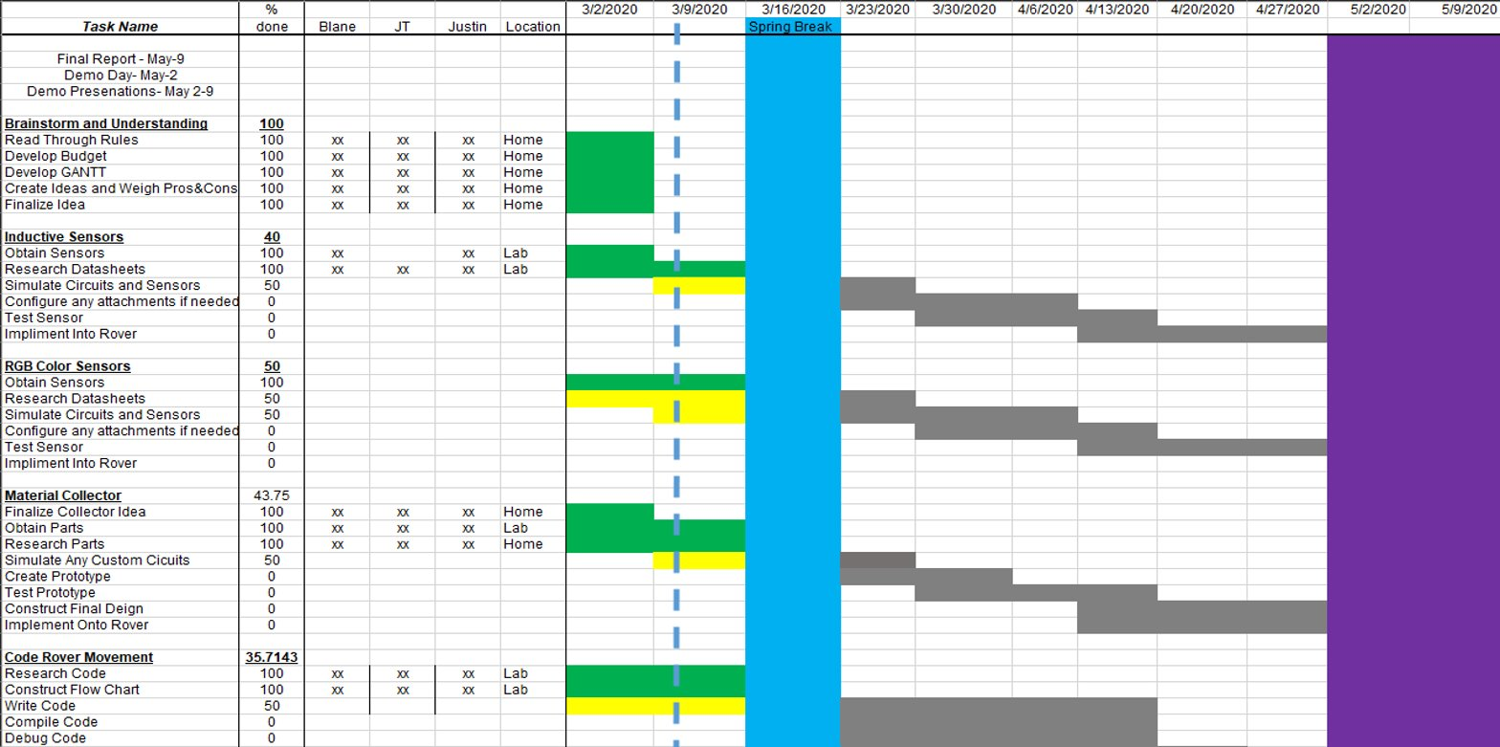
Figure 23: GANTT Chart

Written Lab Report Evaluation Form
Student Name: Justin Collier Course Number: ECE 3331-303
Please score the student by circling one of the responses following each of the statements.
1) The student's writing style (clarity, directness, grammar, spelling, style, format, etc.)
A B C D F Zero
2) The quality and level of technical content of the student's report
A B C D F Zero
3) The quality of results and conclusions
A B C D F Zero
4) Quality of measurements planned/ taken
A B C D F Zero
Grade:

